Experiment: 9
Massive MIMO Capacity vs SNR and Gain Using MATLAB

Objective – 1 Plot of Channel Capacity (bps/Hz) versus SNR (dB).
MATLAB Code:
clc;
clear;
close all;
snr = 0:5:30;
snr_linear = 10.^(snr/10);
capacity = log2(1 + snr_linear);
figure;
plot(snr,capacity,'-o','LineWidth',2,'MarkerSize',6);
grid on;
xlabel('SNR (dB)');
ylabel('Channel Capacity (bps/Hz)');
title('Channel Capacity vs SNR');
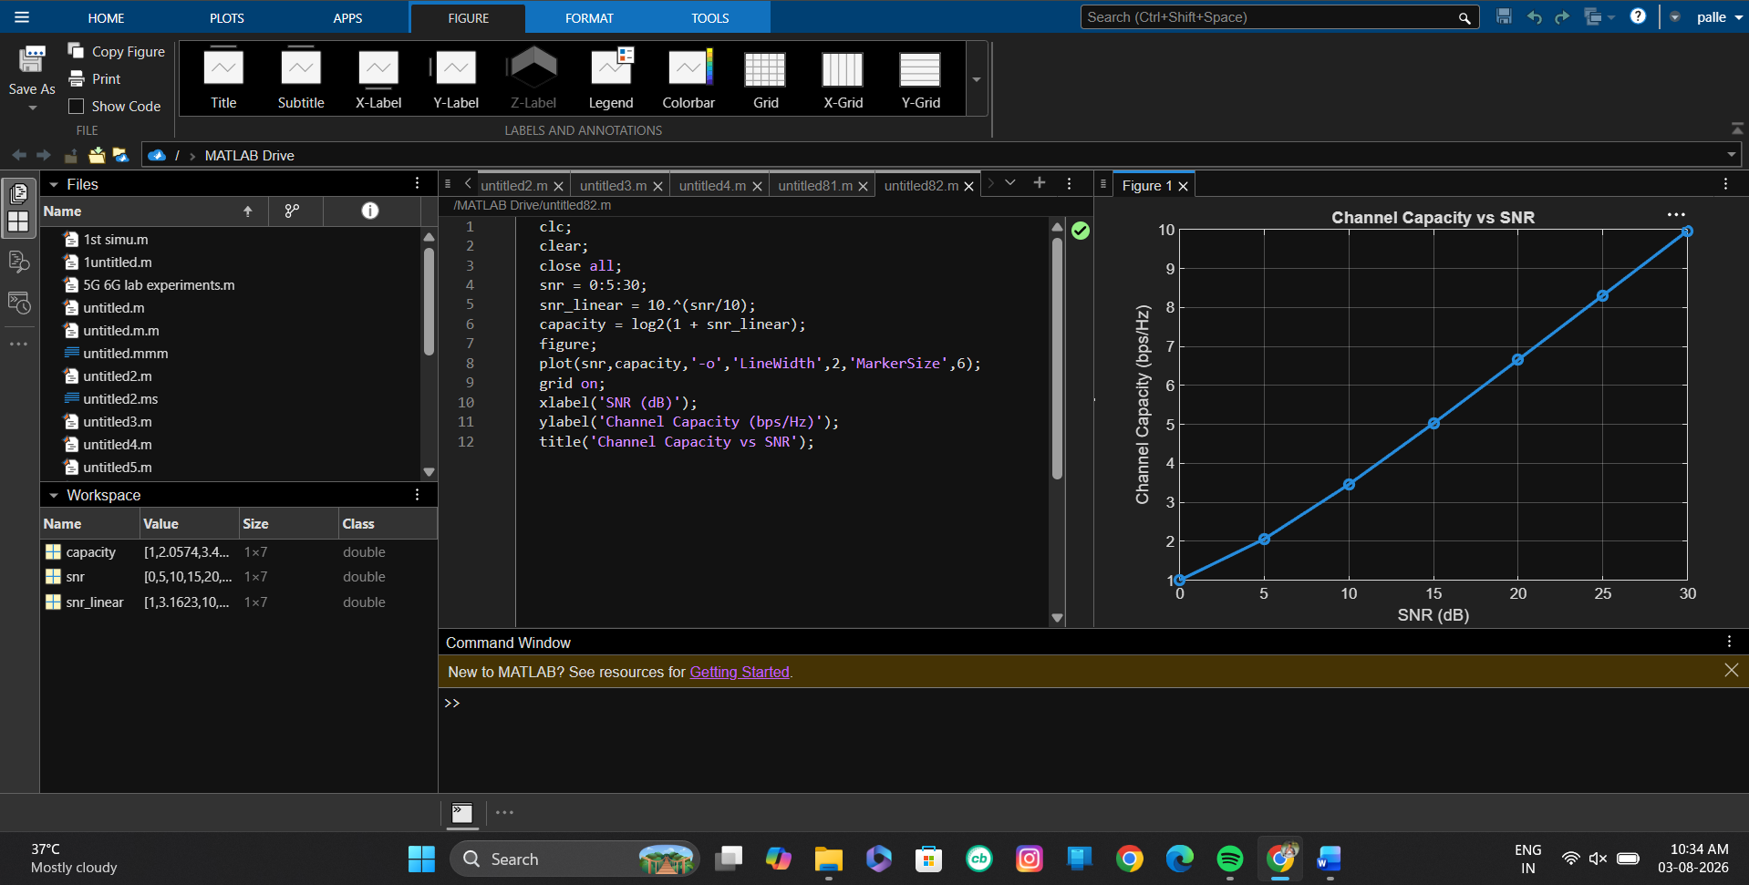
Objective – 2 Bar graph comparing SNR values under different communication scenarios.
MATLAB Code:
clc;
clear;
close all;
snr = 0:5:30;
snr_linear = 10.^(snr/10);
capacity = log2(1 + snr_linear);
figure;
plot(snr,capacity,'-o','LineWidth',2,'MarkerSize',6);
grid on;
xlabel('SNR (dB)');
ylabel('Channel Capacity (bps/Hz)');
title('Channel Capacity vs SNR');
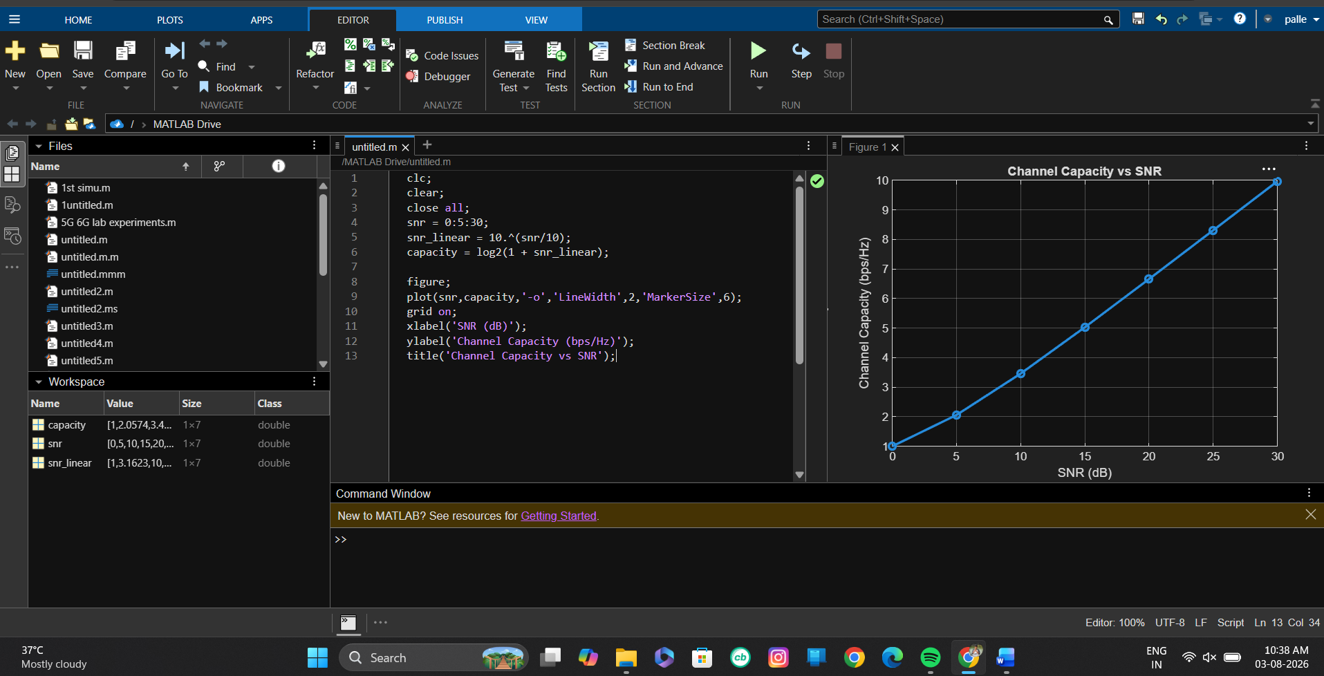

Objective – 3 Bar graph showing Antenna Gain for different antenna array sizes.
MATLAB Code:
clc;
clear;
close all;
antennas = [4 8 16 32 64]; % Number of Antenna Elements
gain = 10*log10(antennas); % Antenna Gain (dB)
figure
bar(antennas, gain)
grid on
xlabel('Number of Antenna Elements')
ylabel('Antenna Gain (dB)')
title('Antenna Gain for Different Antenna Array Sizes')
